­

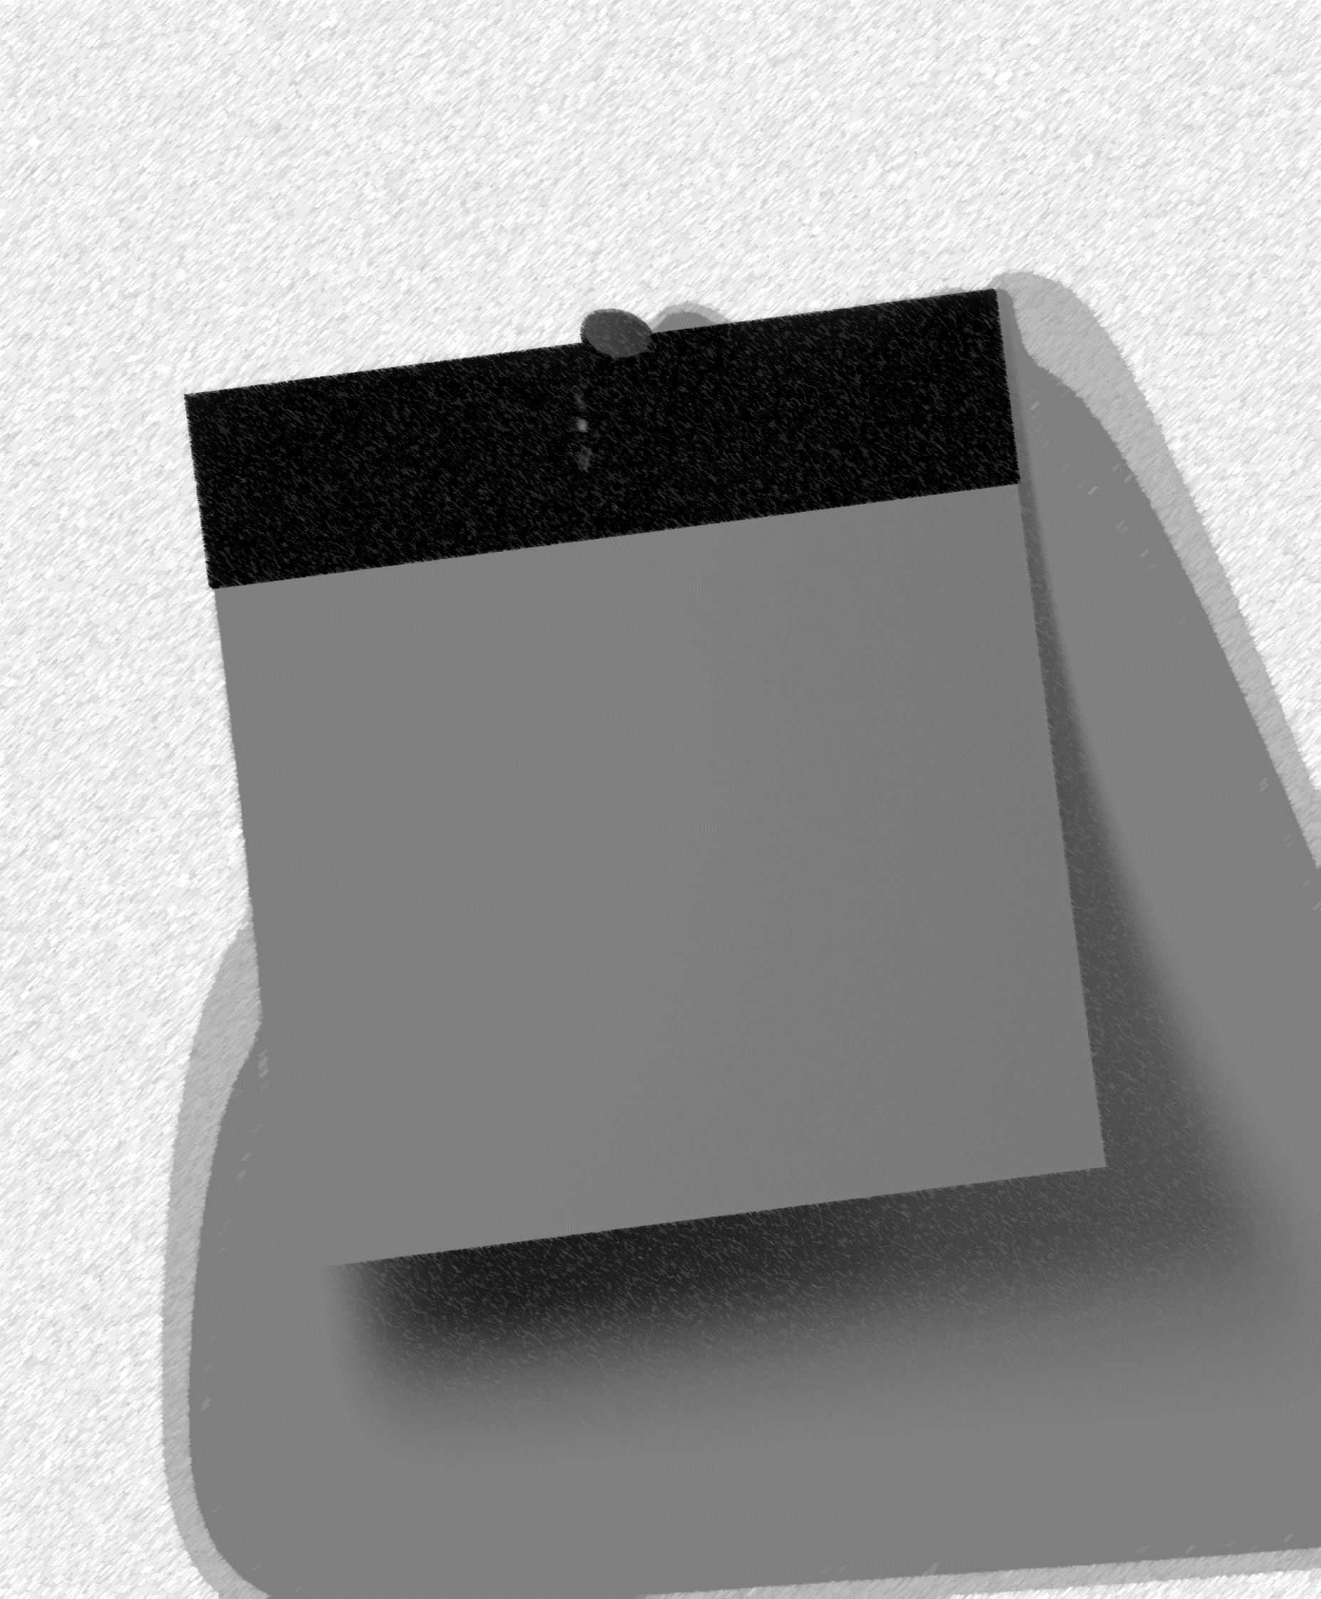

Font-family: IndieFlower-Regular"

Brief Task Description

Brief Task Description

Brief Task Description

**Time t:0 Play**

**Instructions**

STOP/START

Time until Play: _____

**Add Task**

**Add to list:** brief task description

**Video Search by Keyword:**   
i.e. Beyonce, dogs

**Next Task:** Brief Task Description

**Time until Play:** 12 min



**Time t:0 Play**

Instructions

STOP/START

**Add Task**

**Add to list:** brief task description

**Video Search by Keyword:**   
i.e. Beyonce, dogs

Time to PLAY!

**Next Task:** Brief Task Description

